Custom Training

Day 24

**Azure Machine Learning**

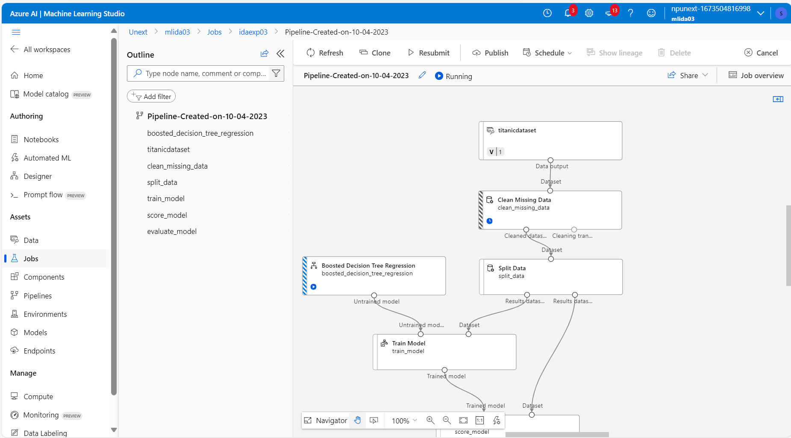

Tune Model Hyperparameters: It optimizes the training model.

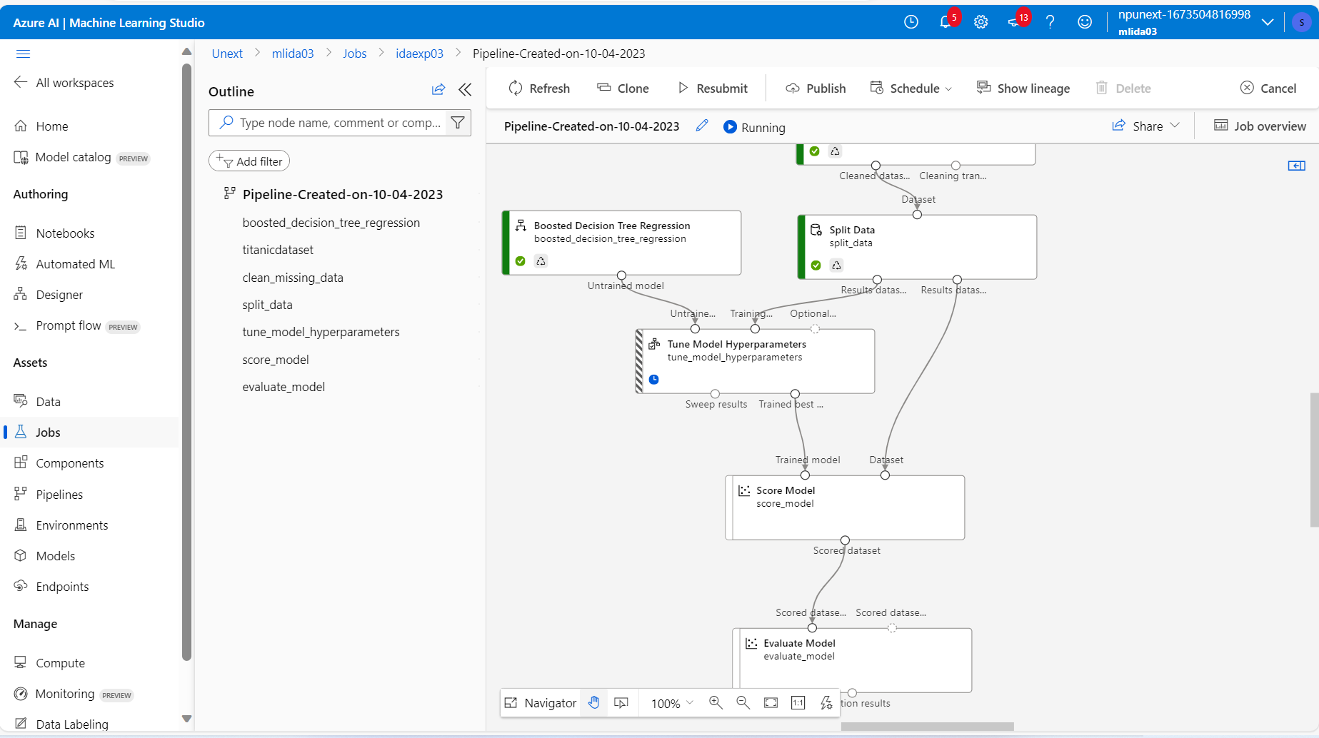

Automated ML:

